req

**Next 3d Brief v2**

**Document Control**

**Objective:** To define requirements to work with next briefing format and maintain / improve automation

**Owner**: Neil Swallow

**Location**: Projects/Next3D/Brief_V2

**Document History**

|  |  |  |  |  |  |
| --- | --- | --- | --- | --- | --- |
| **Step** | **Date** | **Reason** | **Version No.** | **Updated By** | **Approved By** |
| Created | 12/1/15 | 1st Edition | 1.0 | Neil Swallow |  |
| Modified | 4/3/15 | Added screen shots | 1.1 | Neil Swallow |  |
| Modified | 6/3/15 | Added Screen Shots and business logic | 1.2 | Neil Swallow |  |
| Modified | 30/3/15 | Minor changes plus added reporting and Input logic | 1.3 | Neil Swallow |  |
| Modified | 29/6/15 | Minor changes and added Import Logic | 1.4 | Neil Swallow |  |
| Modified | 3/7/15 | Changes to import Logic | 1.5 | Neil Swallow |  |
| Modified | 11.9.15 | Reviewed Comments by Guna | 1.6 | Neil Swallow |  |
| Modified | 11.9.15 | Added Angle Set Option LUT and minor changes | 1.7 | Neil Swallow |  |
| Modified | 18.9.15 | Added Draft excel import colums | 1.8 | Neil Swallow |  |
| Modified | 2/10/15 | Modified Inputs to reflect new client feed | 1.9 | Neil Swallow |  |

**Useful References** (if applicable)

|  |  |
| --- | --- |
| **Reference** | **Location** |
| Automated Data Feed All Areas 290915.xlsx | As above |
|  |  |
|  |  |

|  |
| --- |
| The master of this document is held electronically, when printed the document is uncontrolled and accurate only at the time of printing. If you wish to comment on this document, annotate it and either photocopy it and send it to the owner, or email it to the owner |

**Table of Contents**

Introduction 4

Data Elements 4

Data Logic 5

Sample Brief 5

Lookup Details 5

Texture 1 LUT 5

Texture 2 LUT 6

Option Code LUT 6

Range Code LUT 7

Wrap Code LUT 7

Category Code LUT 7

Fabric Design LUT 7

Season LUT 7

Material Type LUT 8

Foot Shape LUT 8

Detail Code LUT 8

Status LUT 8

Model LUT 8

Sample Screens 9

Login 9

Mass Upload 10

Mass Upload Select Screen 11

Newness Upload Confirmation 12

Range Overview 13

Range Detail Page 14

Batch Management Page 15

ReRender 16

Lookups 17

Lookup Add New 18

Admin 19

New User 20

Reports Selector 21

Phase Status Report 22

Model Creation Report 23

Fabric Status report 24

Import Business Logic 24

Detailed Estimate:- 24

Costing Approved:- 24

Name: 24

(Insert name here) 24

Date: 24

(dd/mm/yy) 24

Approval Signatures 24

# Introduction

Currently the automation used for delivering Next 3d assets is driven via a custom Schawk designed brief, whilst this has served us well in producing the necessary work it is proving difficult for the client to populate and maintain this brief. Next are looking to take an extract straight out of their buyers range plan (internally built ERP system). At the same time where practical we are going to stop using item names (sizes, fabrics, colours etc.) and start using reference codes which will reduce the risk of mismatch as items change name through this production process.

# Data Elements

Currently we take the following data elements out of the brief;

* Range (e.g. Garda)
* Size (e.g. Footstool)
* Fabric
* Fabric Colour
* Foot Type
* Foot Colour
* State (Open / Closed)
* Detail Code (DWOM bedrooms only)
* Camera Angles needed
* Wrap direction / piping options

At a later point in time we receive a 6-2-6 code which we have to rename all renders to including range, size, fabric, fabric colour, foot type and foot colour in the meta data.

In future we will use the following data elements to drive the render process:

|  |  |
| --- | --- |
| **Data Element** | **Explanation** |
| RangeID | 4 digit SGK ID system generated |
| Option | 2 digit numeric code identifying product size  (e.g. 06 = Chair (1Seat) for all fabric ranges) |
| Fabric item Number | 6 digit numeric code identifying fabric type and colour  (e.g. 393432 = Woollen Check Kinross, Ochre) |
| Foot Type | Textual, identifying foot shape  (e.g. Low Tapered) |
| Foot Colour | Textual, identifying foot colour  (e.g. Light) |
| State | Textual, identifying unique model type  (e.g. Open) |
| Wrap direction | Alpha code, identifying wrap and bead method  (e.g. WA) |
| Item Number | 6 digit numeric code identifying the range and the fabric  (e.g. 100030 = Ashford, Woollen Check Kinross, Ochre) |
| Foot Pack Number | 6 digit numeric code identifying the nominated foot type & colour  (e.g. ?????? = ?????? ??????? ????) |

# Data Logic

We need to use the following logic when looking up data from the brief.

Range Name

Select the Range ID from the new brief and use to search in the ranges lookup (see worksheet SS15 Ranges).

Size

Select the Option number and fabric type from the brief and use to search in the Size lookup (see worksheets ‘fabric size codes’ & ‘leather size codes’ these will need to be combined in the actual lookup but with a fabric value added and select where both fabric and option number match).

Fabric

Select Fabric item number from the new brief and use to search in the fabric lookup (see worksheet SS15 Fabric)

Fabric Colour

Select Fabric item number from the new brief and use to search in the fabric lookup (see worksheet SS15 Fabric)

State

TBD

Camera Angles

Select the option and Material type from the brief and use to the select the camera from the camera lookup table.

Wrap direction / piping options

Select the option and fabric Item number from the new brief and use to search the relevant wrap piping options in the Fabric lookup table. Note in order to correctly determine those lines which should pick out of the ‘footstool’ column it is suggested we add an is footstool option against the size lookup.

6-2-6

This comes directly out of the new brief.

# Sample Brief

See reference document

# Lookup Details

# Texture 1 LUT

|  |  |
| --- | --- |
| Element | Description |
| Texture Item Number | Unique Client driven code |
| Texture Name | Descriptor |
| Texture Colour | Sub Descriptor |
| Std Wrap Code | Drop Down list from Wrap Code Lookup |
| Alt Wrap Code 1 | Drop Down list from Wrap Code Lookup |
| Alt Wrap Code 2 | Drop Down list from Wrap Code Lookup |
| Alt Wrap Code 3 | Drop Down list from Wrap Code Lookup |
| Fabric Design | Drop Down list from Fabric Design Lookup |
| Material type | Drop Down list from Material type Lookup |
| Status | Drop Down from the Status lookup |
| Season | Drop Down list from Season Lookup |
| Category | Drop Down list from Category Lookup |
| Date Added | Date format auto generated when record created |
| Date Approved | Date Format auto generate / updated each time element enters approved status. |
| Comments | Free text area |

* Fabric e.g. ‘Versatile Check Sterling Red’

# Texture 2 LUT

|  |  |
| --- | --- |
| Element | Description |
| Texture Item Number | Unique SGK Code. Start at TIN2-001 system will automatically create subsequent codes |
| Texture Colour | Client Descriptor |
| Status | Drop Down from the Status lookup |
| Season | Drop Down list from Season Lookup |
| Category | Drop Down list from Category Lookup |
| Date Added | Date format auto generated when record created |
| Date Approved | Date Format auto generate / updated each time element enters approved status. |
| Comments | Free text area |

* Foot Colour e.g. ‘Dark’

# Option Code LUT

|  |  |
| --- | --- |
| Element | Description |
| Category | Drop Down list from Category Lookup |
| Material Type | Drop Down list from Material Pattern Lookup |
| Option Code | Free Type number |
| Option Description | Free Type Text |
| State | Drop Down list from State Lookup |
| Wrap Code Option | Determines which wrap code is selected from the Texture 1 LUT (Std Wrap, Alt Wrap 1, Alt Wrap 2 etc) |
| Angle Set Option | Drop down from Angle Set Option LUT |
| Main Camera Angle | Free Type Text |
| _1 Camera Angle | Free Type Text |
| _2 Camera Angle | Free Type Text |
| _3 Camera Angle | Free Type Text |
| _4 Camera Angle | Free Type Text |
| _5 Camera Angle | Free Type Text |
| _6 Camera Angle | Free Type Text |
| _7 Camera Angle | Free Type Text |
| _8 Camera Angle | Free Type Text |
| _9 Camera Angle | Free Type Text |
| _10 Camera Angle | Free Type Text |
| _11 Camera Angle | Free Type Text |
| _12 Camera Angle | Free Type Text |
| _13 Camera Angle | Free Type Text |
| _14 Camera Angle | Free Type Text |
| _15 Camera Angle | Free Type Text |
| Date Added | Date format auto generated when record created |
| Comments | Free text area |

* Size e.g. ‘Chair(1Seat)’

## Range Code LUT

|  |  |
| --- | --- |
| Element | Description |
| RangeID | Unique Id System Generated Start with an R. |
| Range Descriptor | Free Text area |
| Bead Option | Drop Down containing Bead, Non Bead and Leather |
| Category | Drop Down list from Category Lookup |
| Angle set Option | Drop Down from Angle set Option LUT |
| Date Added | Date format auto generated when record created |

* Product Range e.g. ‘Alexis’

## State LUT

|  |  |
| --- | --- |
| Element | Description |
| StateID | Unique Id System Generated |
| State Descriptor | Free Text area |
| Date Added | Date format auto generated when record created |

* Product Range e.g. ‘Open or Closed’

## Wrap Code LUT

|  |  |
| --- | --- |
| Element | Description |
| Wrap Code | Free Text area |
| Wrap Code Descriptor | Free Text area |
| Date Added | Date format auto generated when record created |

* Model variant Identifier e.g. ‘WA’

## Category Code LUT

|  |  |
| --- | --- |
| Element | Description |
| Category ID | System generated UID |
| Category Descriptor | Free Text area |
| Date Added | Date format auto generated when record created |

* Denotes business category e.g. ‘Sofas’

## Fabric Design LUT

|  |  |
| --- | --- |
| Element | Description |
| Fabric Design ID | System generated UID |
| Fabric Design Descriptor | Free Text area |
| Date Added | Date format auto generated when record created |

* Family of texture e.g. ‘Stripe’

## Season LUT

|  |  |
| --- | --- |
| Element | Description |
| Season ID | System generated UID |
| Season Descriptor | Free Text area |
| Category | Drop Down list from Category Lookup |
| Date Added | Date format auto generated when record created |

*Definition of activity phase e.g. ‘Spring 1 15’

## Material Type LUT

|  |  |
| --- | --- |
| Element | Description |
| Material Type ID | System generated UID |
| Material Type Descriptor | Free Text area |
| Date Added | Date format auto generated when record created |

e.g. ‘Fabric’

## Foot Shape LUT

|  |  |
| --- | --- |
| Element | Description |
| Foot Type ID | System generated UID – 4 digit starting with F ie F001 |
| Foot Type Descriptor | Free Text area |
| Date Added | Date format auto generated when record created |

* Description of type of feet e.g.’Block’

## Detail Code LUT

|  |  |
| --- | --- |
| Element | Description |
| Detail Code ID | Free Text Area |
| Detail Descriptor | Free Text area |
| Date Added | Date format auto generated when record created |

* Model variant Identifier e.g. ‘SCF’

## Status LUT

|  |  |
| --- | --- |
| Element | Description |
| Status ID | System generated UID – 3 digit |
| Status Descriptor | Free Text area |
| Status Category | Texture, Model, Range/Batch |
| Date Added | Date format auto generated when record created |

* status used in tracking elements e.g. ‘Approved’

# Model LUT

|  |  |
| --- | --- |
| Element | Description |
| Model Name | Created by the upload of the client data feed |
| Category | Drop Down List from Category Lookup |
| RangeID | Drop Down List from Range Lookup |
| Option | Drop Down List from Option Code Lookup |
| State | Drop Down from State Lookup |
| Detail Code | Drop Down list from Detail Code Lookup |
| Foot Shape | Drop Down list from Foot shape Lookup |
| Wrap Code | Drop Down List from Wrap Code Lookup |
| Status | Drop Down from the Status lookup |
| DataSeason first added | Drop Down list from Season Lookup |
| Date Added | Date format auto generated when record created |
| Date Approved | Date Format auto generate / updated each time element enters approved status. |
| Comments | Free text area |

* Denotes c4d model e.g. ‘IJ12_01_Open_NA_F001_WA’

Note the Model LUT is the only LUT for which new lines cannot be added manually as this will be generated automatically view upload of the newness templates (see model upload page).

## Angle Set Option LUT

|  |  |
| --- | --- |
| Element | Description |
| Angle Set Option ID | System generated UID – 3 digit |
| Angle Set Option | Free Text area |
| Date Added | Date format auto generated when record created |

* used to determine which Angle set should be used when selecting out of the Option Code LUT.

# Sample Screens

## Login

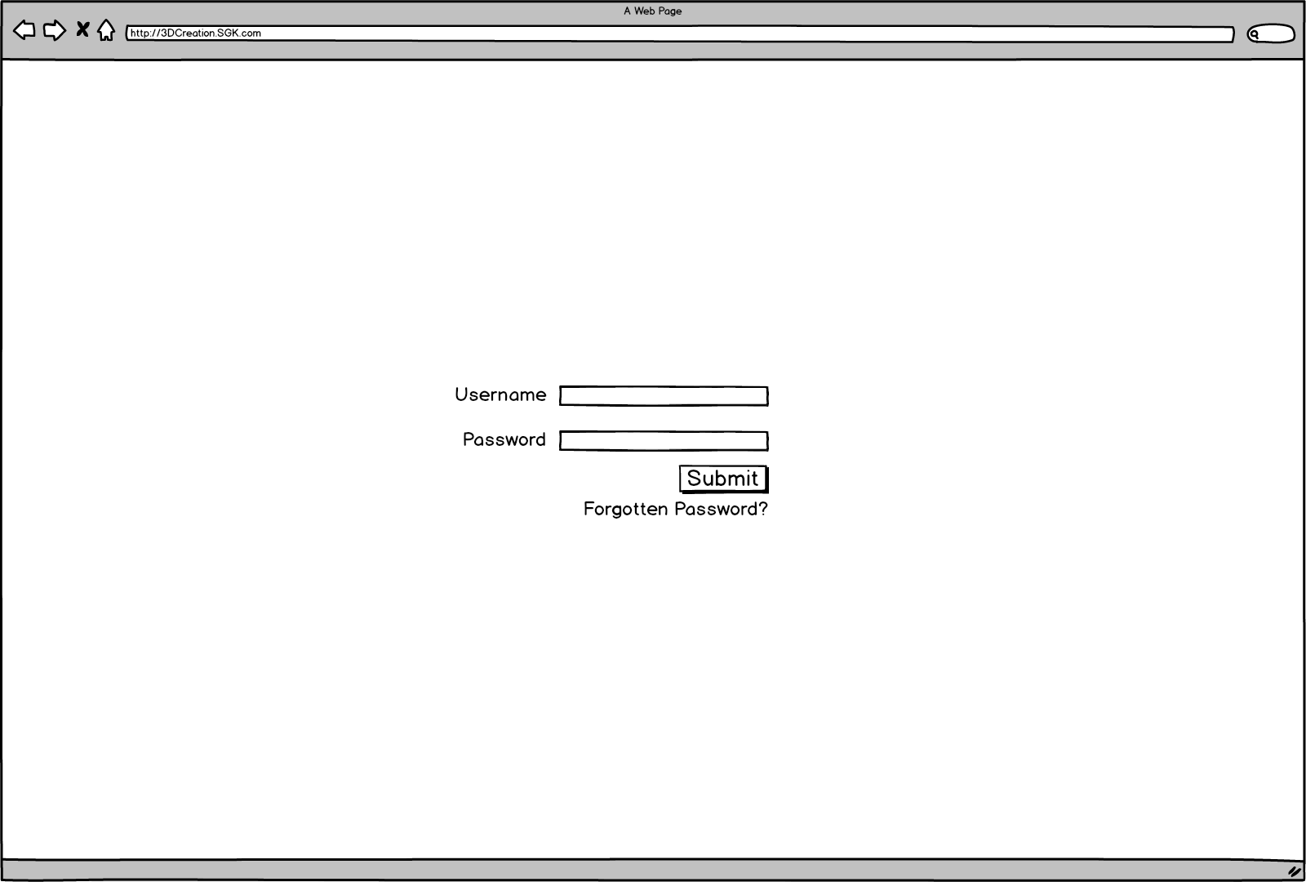

Login screen allows authorised users to login to the system; unsuccessful login attempts will be given an error message. Successful login attempts will be forwarded to the ‘Range Overview’ page. Forgotten password link will not be required if system is linked to SGK active directory. If not linked to SGK active directory ‘Forgotten Password’ link will bring up a pop up asking for email address and if the email address links to a valid account forward a temporary password to that email account.

## Mass Upload

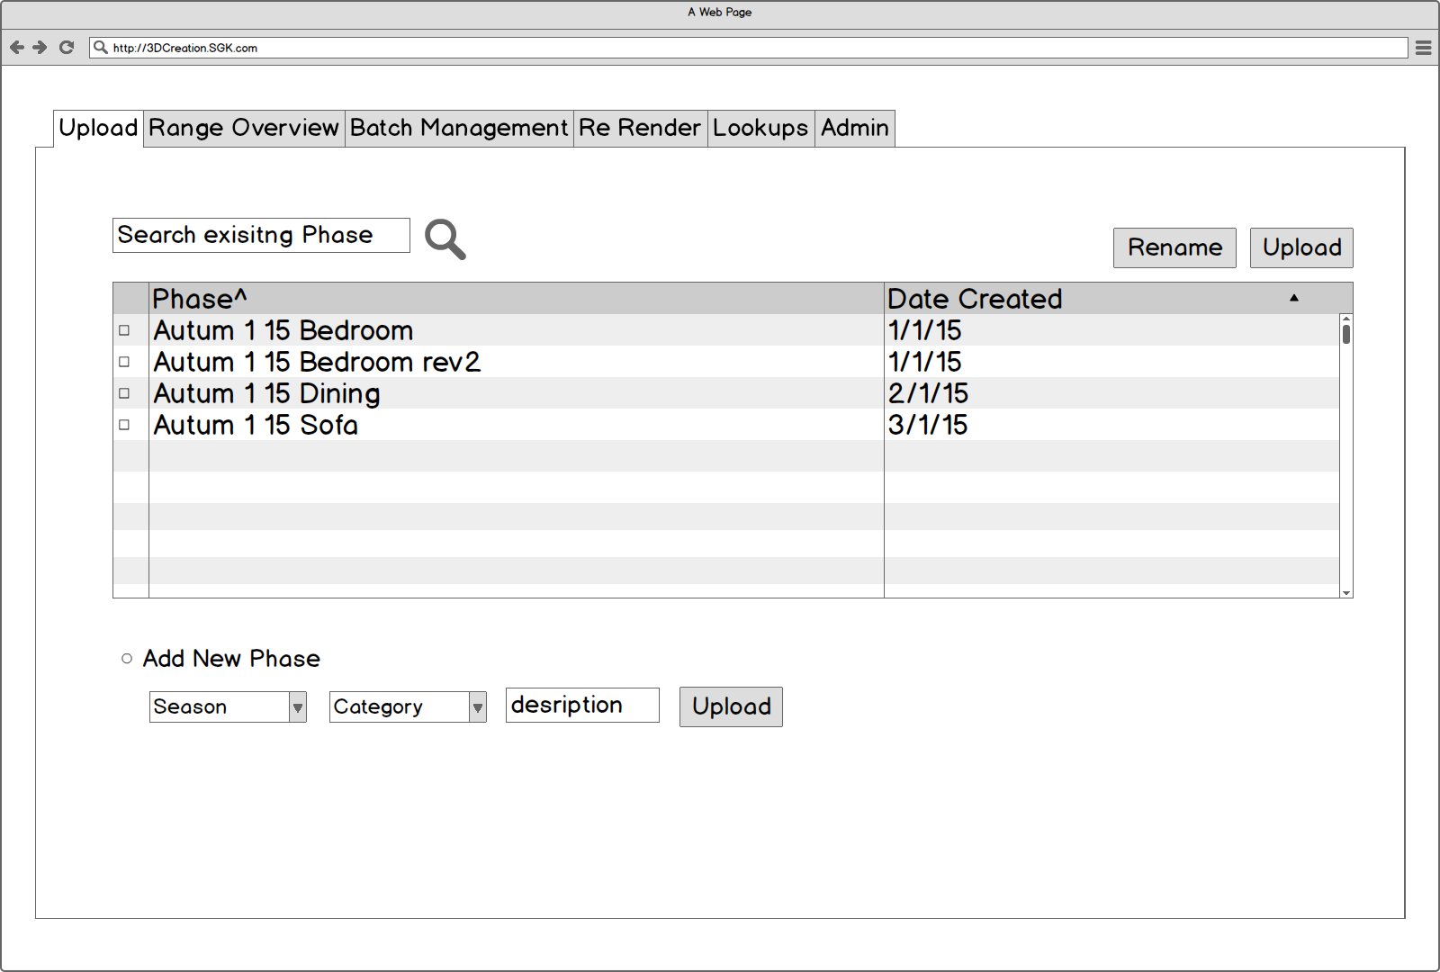

When loading this screen the phases for all current seasons (not marked as complete in the Season Lookup) will display in the table, these are searchable and the user can rename the phase or upload a replacement data feed (excel).

Alternatively a user might create a new phase selecting the relevant Season and adding a description if required should a phase for the provided excel data feed not already exist in the table above. When selecting either upload a popup will appear asking for the file to be uploaded.

## Mass Upload Select Screen

# 

The mass upload select screen would allow the user to select and submit an excel file for upload. System should check the file selected is an excel and warn if not. Once submitted information will be consumed into system (see upload logic section) user is forwarded to the ‘Range Overview’ Screen for new and existing phases

If the excel is not formatted as expected show error to user.

## Newness Upload Confirmation

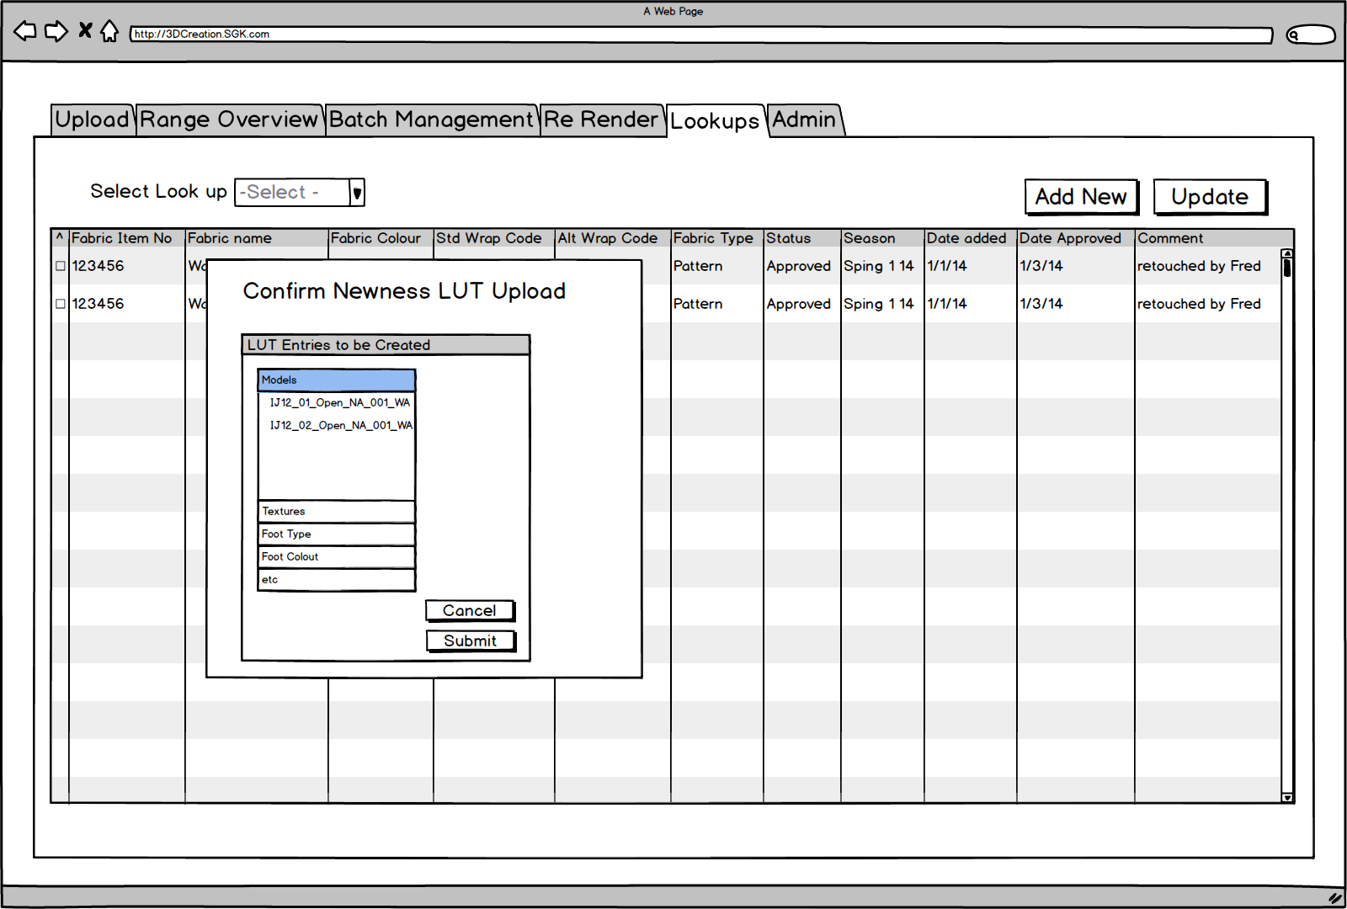Once a Newness excel has been loaded the following popup is shown before directing the user to the lookup table screen.

This screen confirms all elements, which are expected in the data feed which are not already in the relevant LUT. Cancel will abort the whole import function, Submit will create the relevant issues in the LUT’s.

## Range Overview

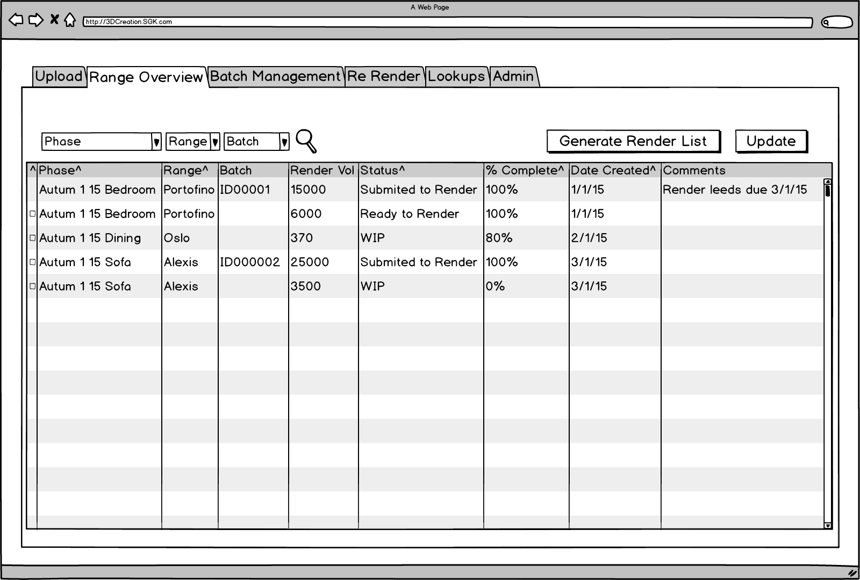

Screen shows all current phases (a definition of a current phase = a phase who’s season is not marked as complete in the season lookup) split by range. This table can be filtered by phase, range or batch Id. To enable editing of the status and comments fields the users needs to first select the radio button at the start of the row, this will enable the status and comments field to be editable, users will select update once changes have been made.

Hyperlinks from

Range > Range detail page

Batch > Batch Management page

Selecting the ‘Generate Render List’ button will;

Items are assigned the next available BatchID

Create a CSV file to current ‘job list format’

Change status of selected lines to ‘Render worklist created’

Send Email to xxx.com

Confirmation of success is given to user as a popup

If multiple lines are selected (user can only select multiple lines within the same season) only one worklist batch is generated and all lines get the same batchID.

## Range Detail Page

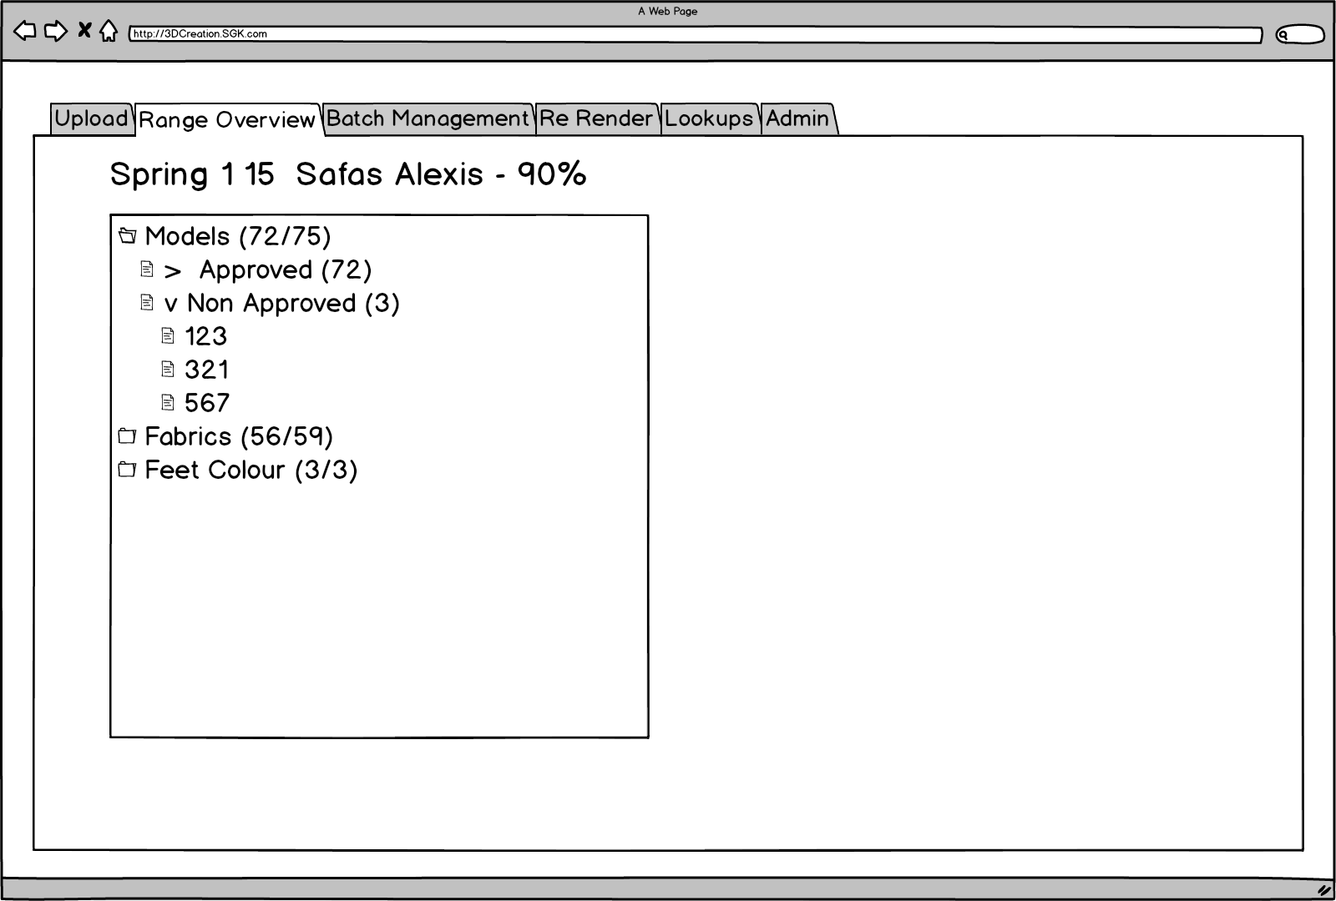

The Range detail page loads when selecting the range from the range overview page and shows a summary of the range plus the % of items needed to generate the render list which are complete (in this case 90%). The table allows the user to drill down into the detail of which items are not approved. By default this tree loads rolled up to the top level showing a summary of the models, fabrics and feet colours needed with a determination of the current status. Selecting a heading will take the user through to the look up table for that content type, if the user selects a specific entry the lookup will be filtered to that item.

## Batch Management Page

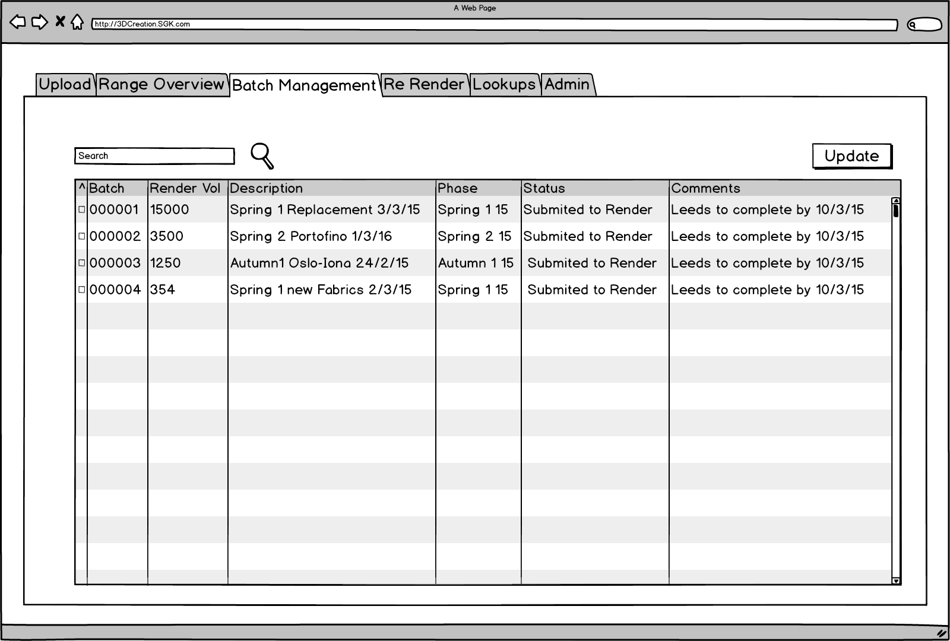

The batch management screen will by default show all batches related to seasons, which are not completed. User should be able to filter on season and Status to reduce the list.

To enable editing of the status and comments fields the users needs to first select the radio button at the start of the row, this will enable the status and comments field to be editable, users will select update once changes have been made.

## ReRender

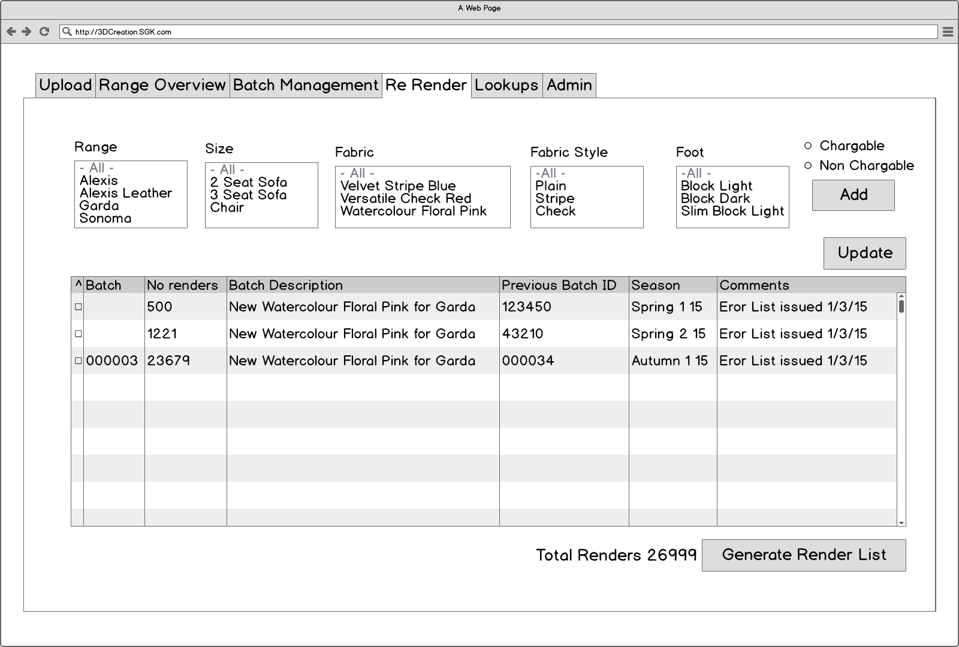

User will select the options (range, Size, Fabric, foot all multi selects) to define the images to be re rendered (Note these renders must already exist).

Once options are selected user must select either Chargeable or non chargeable.

When clicking add system will check elements are in an approved state (if al are not approved, no items will be added to table and a popup will indicate which items are not approved) and generate batches by season and add to the table below. Please note if any of the models or textures are set to discontinued do not re render that image.

User can continue adding further re-renders which will combine into the relevant batch by season in the batches table below. Batch numbers will only be assigned when the user selects to submit to render.

Users can type a description and comments about the batch prior to generating the render list which will create a CSV for each batch. This will also generate an email to production user email.

## Lookups

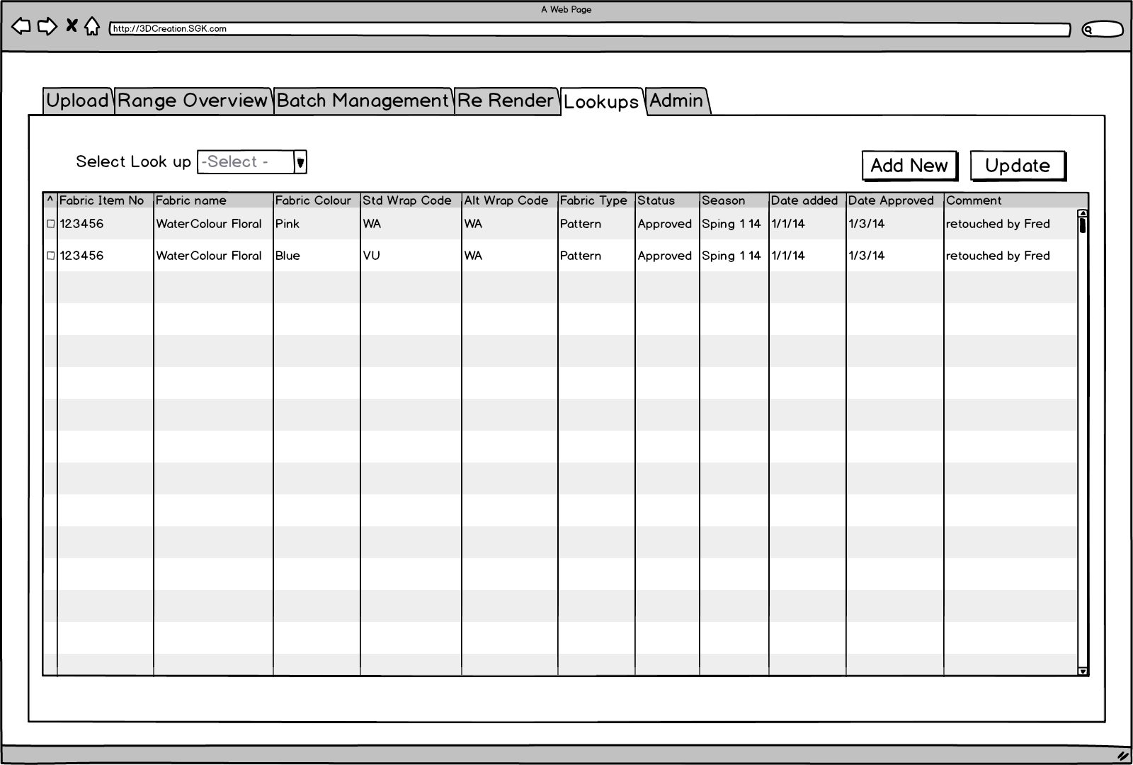

When loading the lookup screen the user will be presented with a drop down list to select the lookup table they wish to select. Selecting the relevant dropdown will load the lookup table showing the relevant columns for that lookup (see lookup detail section). Users can update all of the data in the lookup by selecting the relevant row checkbox, changing the data and selecting the update option.

Selecting the add new option will open the add new popup with the form populated for the relevant lookup.

## Lookup Add New

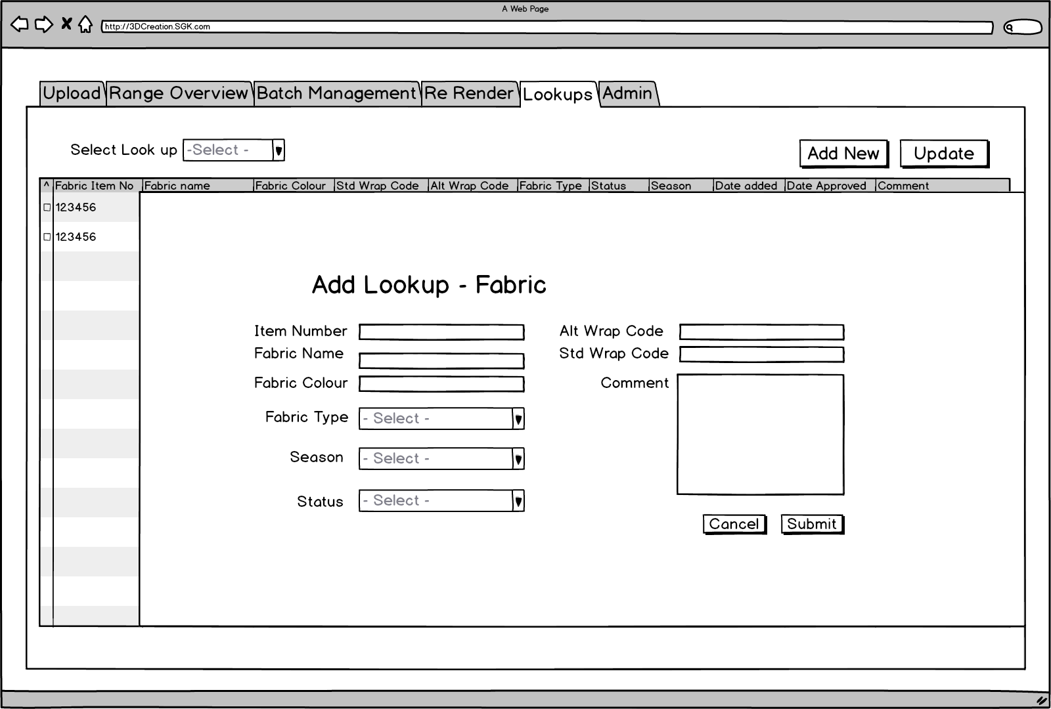The form within the lookup is determined by the relevant lookup item (see Lookup detail section for information).

## Admin

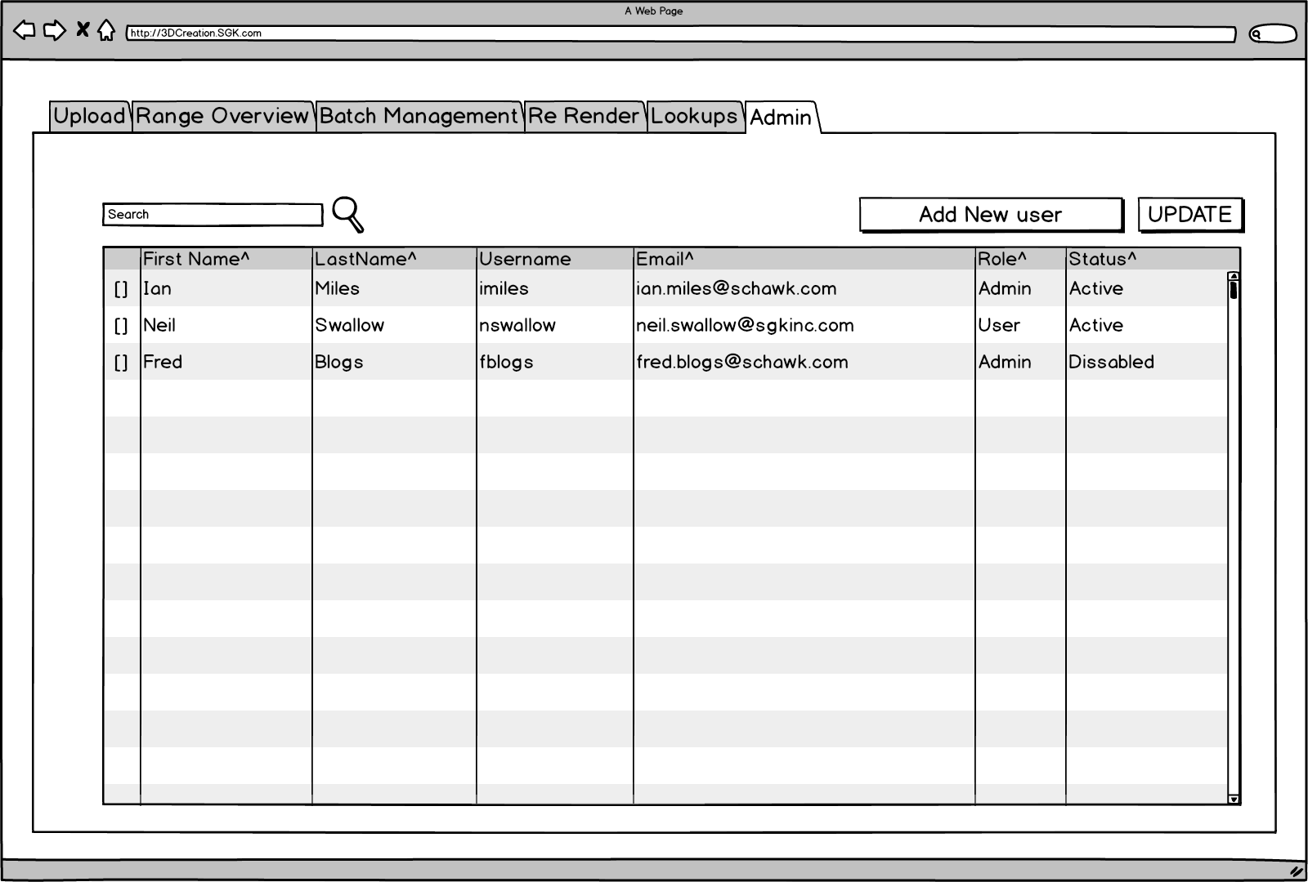

Admin screen loads to show first 50 users, if the user needed is not in the list user must search.

If system is linked to active directory the only items editable will be role and status otherwise all data is editable via the usual checkbox and update button.

User Types;

Admin can view, edit and update all data

CS User Can view, edit and update all data except the ability to add and edit users.

Production User can NOT add / edit lookups. They can also NOT add or edit users.

Read only User can only view data in the system.

Selecting the add new user button will load the new user popup.

## New User

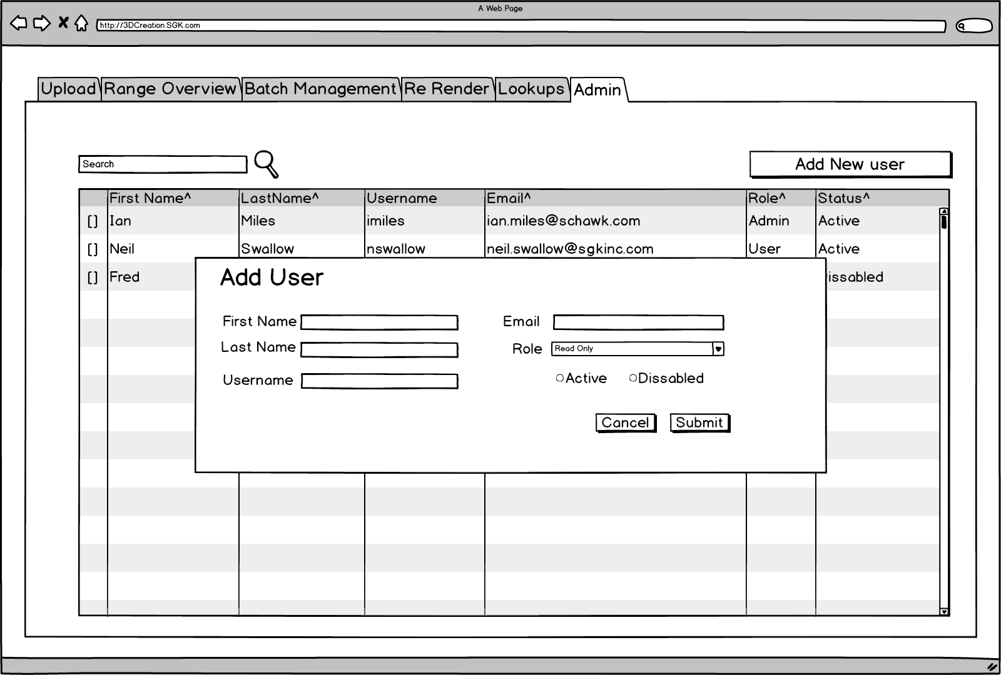

This screen gives the ability to create new users. Ideally system will be tied to SGK AD

when new user is created a welcome email is sent if no AD integration this would include temp password with link to set new password.

**Reports**

## **Reports Selector**

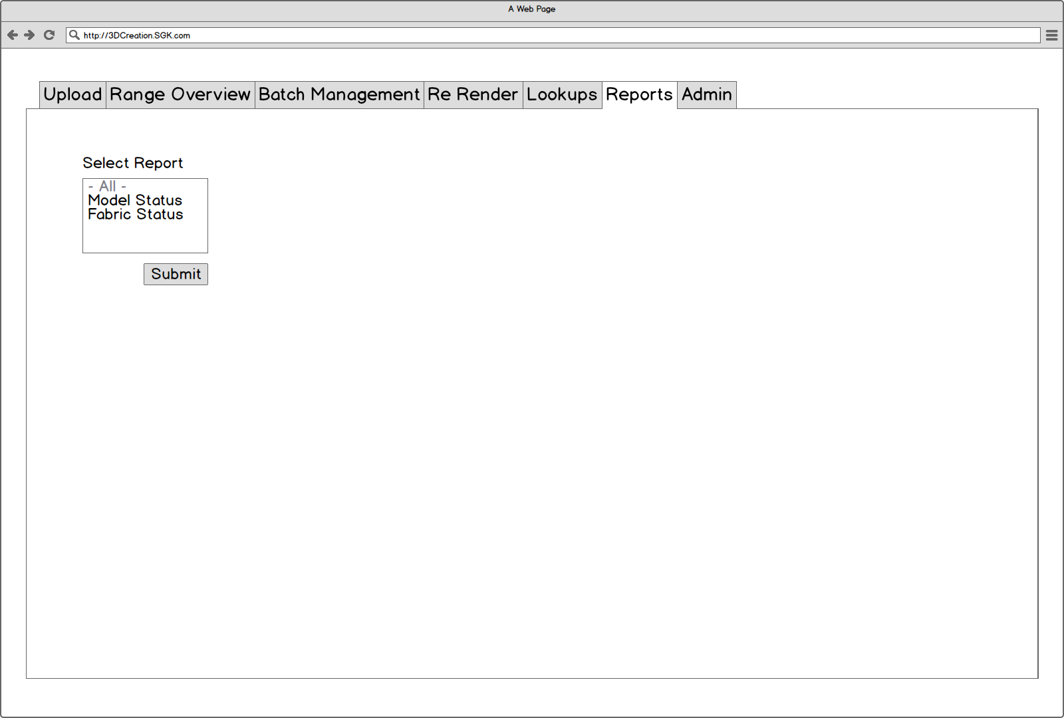

Report selector screen shows a drop down list with the reports available. User can select a reports and submit to be forwarded to the relevant report screen.

## Phase Status Report

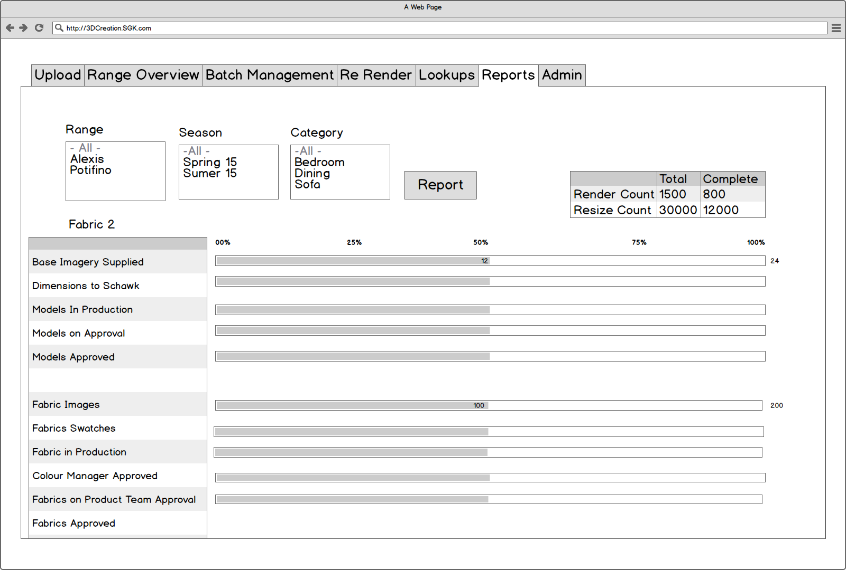

The Phase Status report give a headline view on the current status of set elements.

The report looks at the status of;

Renders looking at a count of the number of elements in each status (Base Imagery Supplied, Dimensions to Schawk, Models in Production, Models on Approval, Models Approved).

Fabrics looking at a count of the number of images in each status (Fabric Images, Fabric Swatches, Fabric in Production, Colour Manager Approval, Fabrics on Product team approval, fabrics approved).

Count of total renders needed / created

Count of total Resize images needed / created.

## Model Creation Report

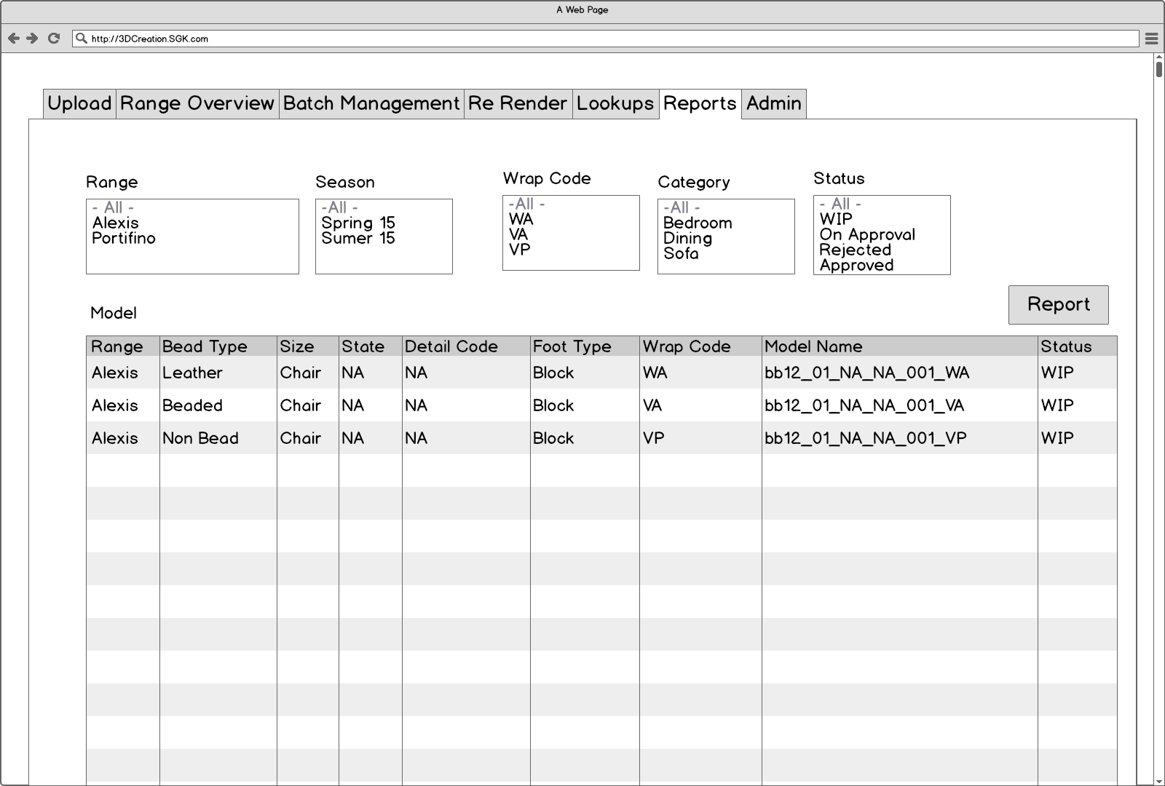

Report showing attributes and status of models.

## Fabric Status report

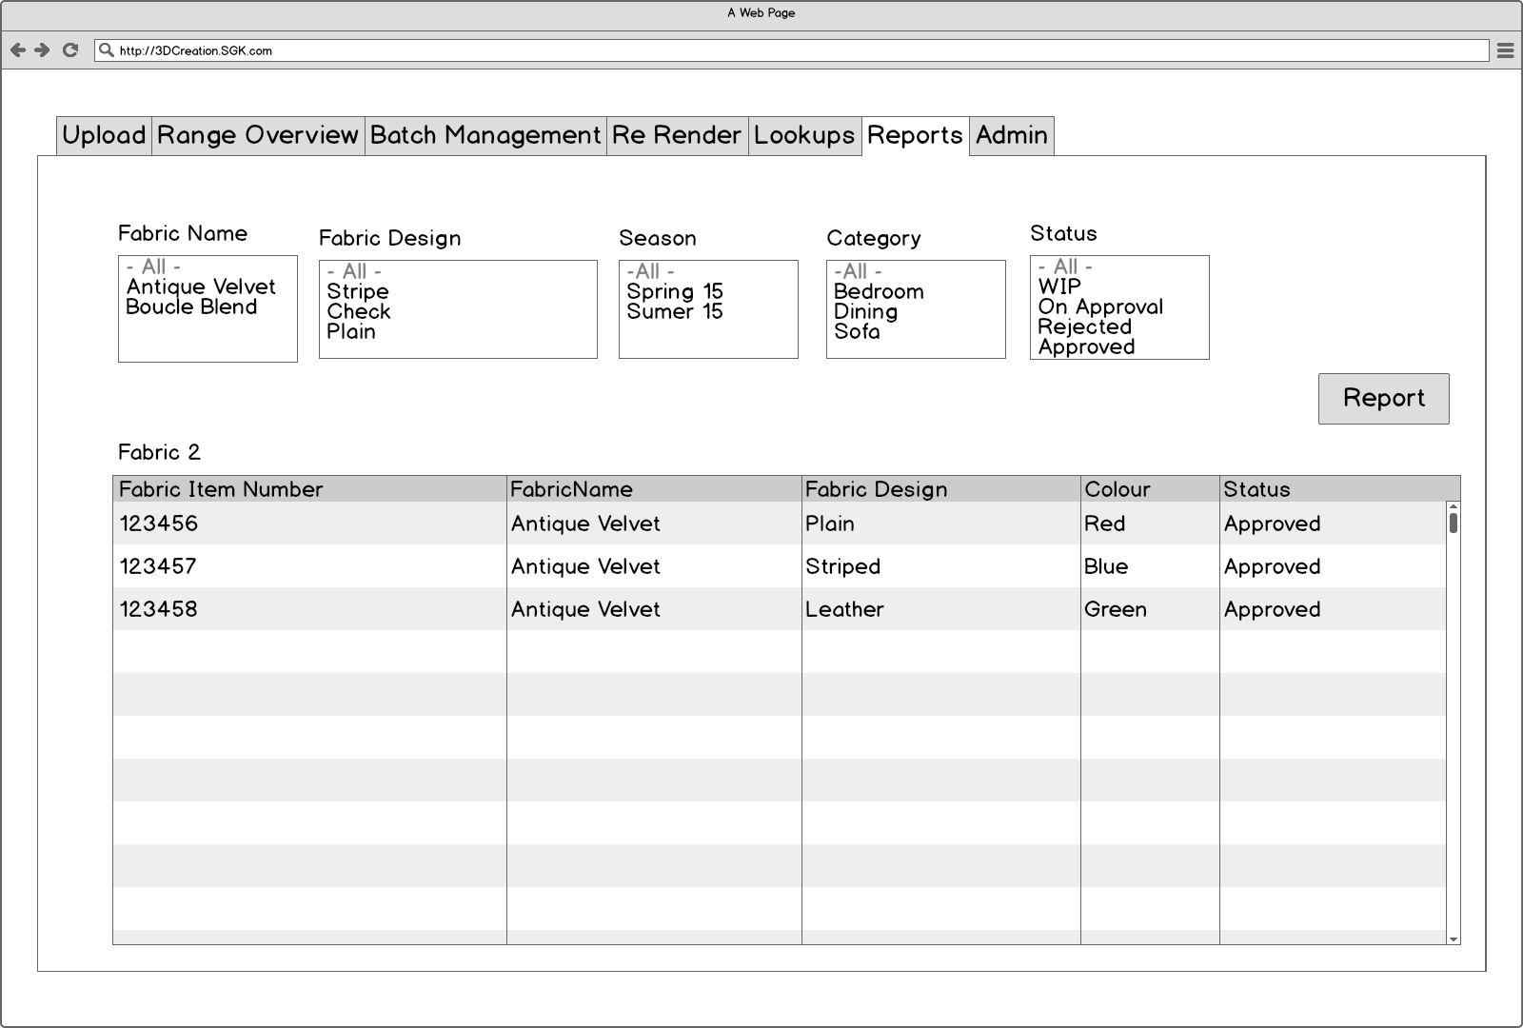

Report showing attributes and status of fabrics

# Import Business Logic

When importing a data feed spreadsheet we need to follow the following logic;

1. Import uploaded excel file
2. Find Sheet xxx
3. Define number of items to be imported;
   1. All rows which contents of ‘Shape_Start_Phase’ or ‘Fabric_Start_Phase’ or ‘Foot_Start_Phase’ matches the Season selected when uploading the data from the Mass upload screen.
4. Define which imported rows need duplicate entries due to multiple state in the option codes.
   1. Use Material codes from excel and Texture 1 LUT to determine the Material type.
   2. Use the Option Code and Range from excel and material type defined above to look up all matching entries in the Option Code LUT
   3. For each matching go to next step. Note if there are multiple matches store multiple lines.
5. Store the following data for each matched entry

|  |  |  |  |
| --- | --- | --- | --- |
| Data Element | Excel Column | Mandatory? | Notes |
| Unique system generated ID | Not in excel | Y | Not in excel generated on import |
| Season | Not in excel | Y | Defined on the upload |
| Category | Not in excel | Y | Defined on the upload |
| Description | Not in excel | Y | Defined on the upload |
| Status | Not in excel | N |  |
| Item Number | A | Y | First 6 of 6_2_6 |
| Option Code | A | Y | Middle 2 of 6_2_6 force to be 2 characters if less than 10 |
| Foot Pack Number | A | N | Last 6 of 6_2_6 if there is no last 6 add NA |
| Fabric Item Number | I | Y | Defines the Fabric type and Colour |
| Foot Type | M | Y | Long Text tie up to Foot Type LUT Description |
| Foot Colour | N | Y | Long Text tie up to Foot Type LUT Description |
| Detail Code | P | Y | As defined in data feed |

Note any cells which contain ‘not required’ should be replaced with NA.

### Detailed Estimate:-

|  |  |
| --- | --- |
| Scoping: |  |
| Documentation: |  |
| Design: |  |
| Coding: |  |
| Testing & Rework: |  |

### Costing Approved:-

(State name and date)

|  |  |  |  |
| --- | --- | --- | --- |
| **Name:** | (Insert name here) | **Date:** | (dd/mm/yy) |
| Name: | (Insert name here) | Date: | (dd/mm/yy) |

# Approval Signatures

Schawk

|  |  |  |  |
| --- | --- | --- | --- |
| **Name:** | xxx | **Job Title:** | xxx |
| **Signature:** |  | **Date:** |  |

Requestor (Client)

|  |  |  |  |
| --- | --- | --- | --- |
| **Name:** | xxx | **Job Title:** | xxx |
| **Signature:** |  | **Date:** |  |

Approver (Client)

|  |  |  |  |
| --- | --- | --- | --- |
| **Name:** | xxx | **Job Title:** | xxx |
| **Signature:** |  | **Date:** |  |